LARGEST NUMBER

EXPNO : 8

AIM : To write an assembly language program to implement largest number using 8085 processor.

ALGORITHM:

1. Start the program by loading the first data into the accumulator.
2. Move the data to a register.
3. Get the second data and load into the accumulator.
4. Add the two register content.
5. Check for carry.
6. Store the value of sum and carry in the memory location.
7. Halt

PROGRAM:

LXI H,2050

MOV C,M

DCR C

INX H

MOV A,M

LOOP1: INX H

CMP M

JNC LOOP

MOV A,M

LOOP: DCR C

JNZ LOOP1

STA 2058

HLT

INPUT:

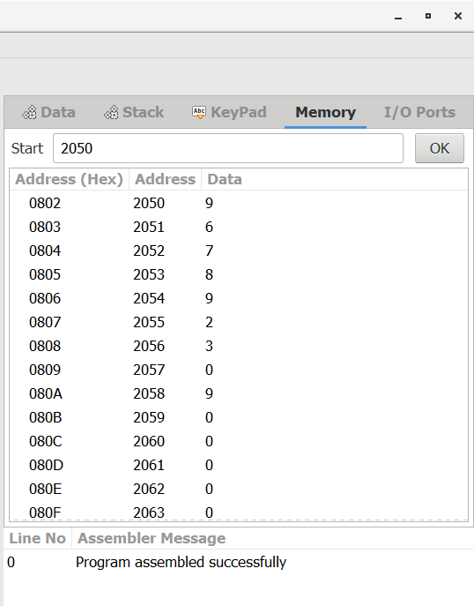

OUTPUT:

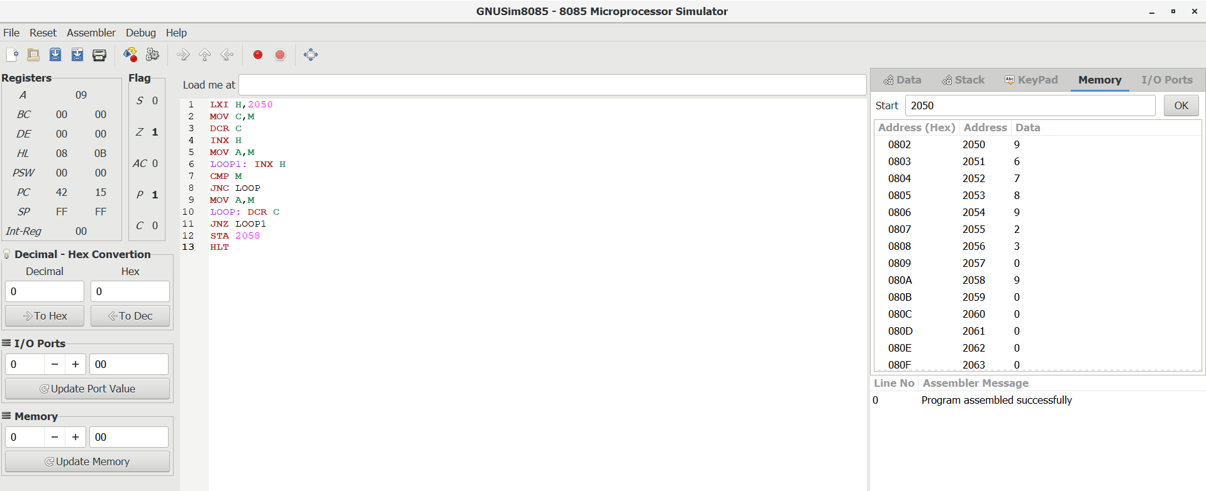

RESULT: Thus the program was executed successfully using 8085 processor simulator.